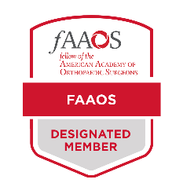
How to Add the FAAOS Digital Badge to Your Outlook Email

Download your FAAOS Digital Badge from the FAAOS Recognition page.

Click File in the upper-left hand corner of your Outlook window
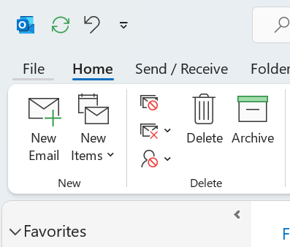

Select Options on the bottom left hand corner
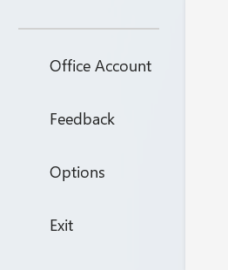
A new window will open. Select Mail on the left hand side and then click on Signature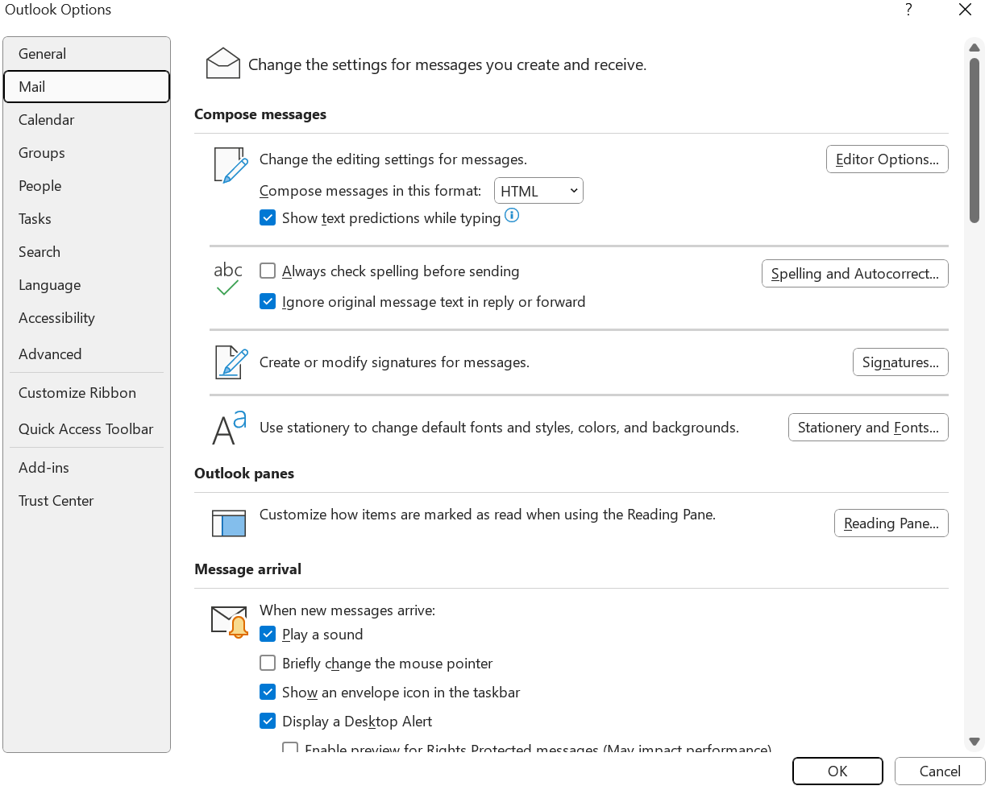

Select the signature you would like to edit or create a new one
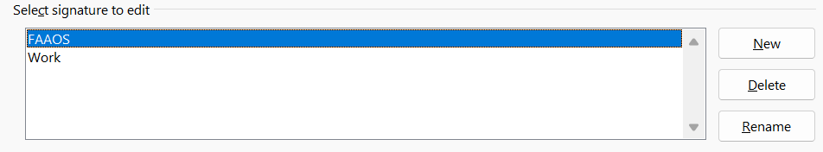

Copy and paste template below to the signature box and add your information

 | Your Name  Title  Department  Email Address  Phone Number  Website  Office Address

Fill in your information
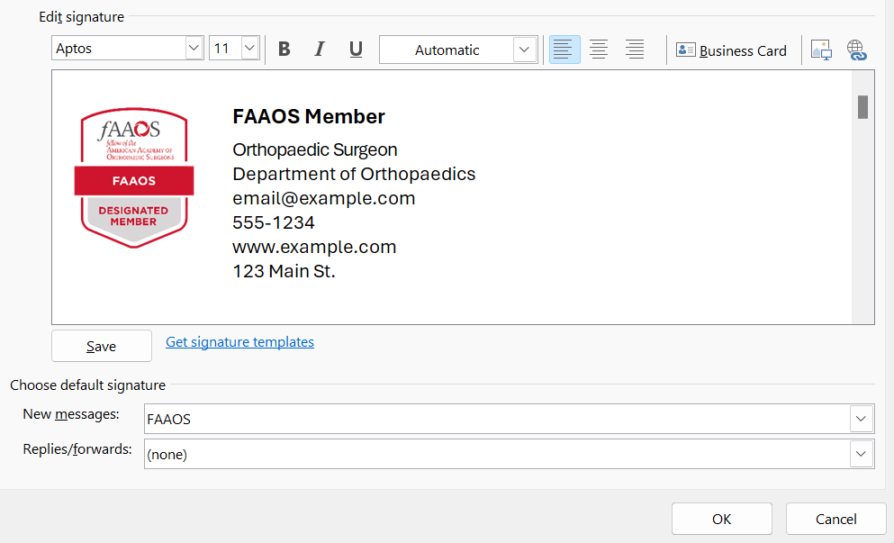

Select Ok to save your changes

